

**How To use Google Chrome Extensions**

By Nicholas Halstead

Virginia Polytechnic Institute and State University

**Before You Begin:**

**What Is a Google Chrome Extension?**

Google Chrome is a web browser, technology that helps you use the Internet. A Google Chrome Extension is something that can make that easier.

**What Can an Extension Do?**

There are many Google Chrome Extensions, and they

have a wide range of functions. All of them are confined to working on Google Chrome. Some extensions can block advertisements, others ensure better Internet privacy, and others can prevent Internet browsing delays.

**General Warnings**

Not all Google Chrome Extensions made by Google, and some can even harm your computer. It is

important to practice Internet safety by evaluating an extension before you add it. While Google Chrome does provide warnings on potentially harmful extensions, it is good practice to note the rating and read the reviews on extensions (more on this later).

**Discovery**

The purpose of this user document is to foster

competency in discovery. After reading this document, users should have a better understanding on Chrome Extensions to be able to discover on their own.

**Prerequisites**

Before you can begin adding Google Chrome

Extensions, you must first have Google Chrome. If you do not already have it, search the Internet for "how to download Google Chrome". There are plenty of simple and free tutorials to follow.

Additionally, you should have a basic understanding on how to operate the computer you are using (how to open Chrome, move the mouse, click objects on the screen, and use the keyboard).

**How To use**



**Google Chrome Extensions (1)**



OPEN UP GOOGLE CHROME

Locate this icon on your com puter and click it to open Google Chrom e.

*Google Chrome icon*



|  |  |
| --- | --- |
|  | SEACH FOR THE GOOGLE |
|  | CHROME EXTENSION STORE |
|  | **Either use the box at the top ofthe screen or go to** |
|  | **w w w .google.com** |
|  | **Type in the box " Google Chrom e Extensions" and** |
| *Google home page* | **press enter.** |
|  |  |
|  |  |

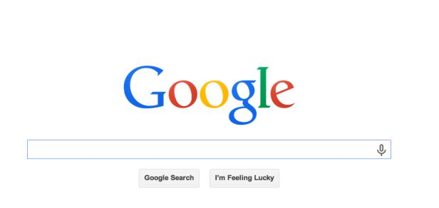

CLICK ON THE FIRST LINK

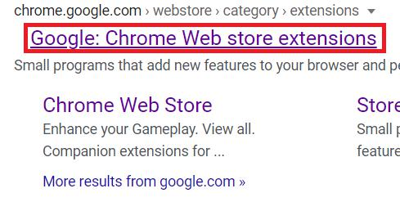

**Your screen should have the result like this picture. Click on the first result in the red box. This w illtake you to the Chrom e W eb Store.**

*Google result*



|  |  |  |  |  |
| --- | --- | --- | --- | --- |
|  |  |  | LOCATE THE SEARCH BAR | |
|  |  |  | **Find the search bar (show n w ith a red box) on your** | |
|  |  |  | **screen. Type w hat you w ant to search for here. This** | |
|  |  |  | **docum ent w illshow an exam ple ofone extension, but** | |
|  |  |  | **there are m any others you can search for.** | |
| *Chrome Extension search bar* | | | **Type in " ad block" for the first exam ple.** | |
|  |  |  |  |  |
|  |  |  |  |  |
|  |  |  | CLICK ON THIS RESULT | |
|  |  |  | **M any results w illcom e up, but click on this one** | |
|  |  |  | **pictured called " AdBlock -- best ad blocker"** | |
|  |  |  | **Follow the next instructions by clicking on the** | |
|  |  |  | **buttons in the red box** | |
|  |  | *AdBlock Extension that I use* |  |  |
|  | | |  |  |
|  |  | |  |  |
| *AdBlock store page* | | |  |  |

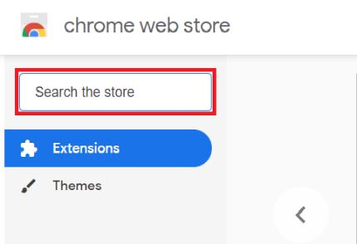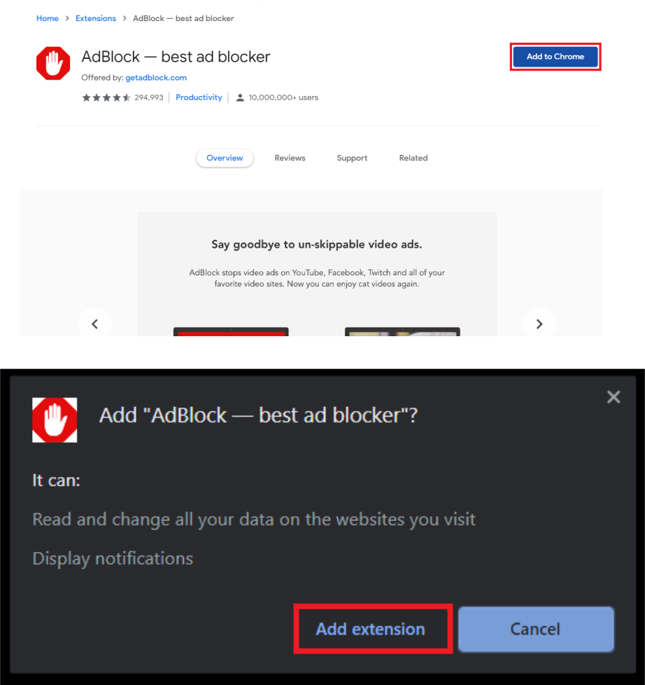

*AdBlock add extension button*



**THIS USER DOCUMENT HAS BEEN PREPARED BY**

N icholas H alstead at Virginia Tech

**How To use**

**Google Chrome Extensions (2)**



CLOSE ANY ADDITIONAL PAGES

An additionalpage m ay popup asking for a donation, but you can close this page w ithout affecting the ad blocker.



NOTE THE PERMISSION SETTINGS

This adblocker asks to read/w rite data on w ebpages you visit. I use this adblocker, so Iknow it is not a virus. H ow ever, you should be carefulofthese perm issions and look at review s of an extension and the rating beforehand to see ifother users had problem s from it before you add an extension.



**How To remove Google Chrome Extensions**



LOCATE THIS SYMBOL

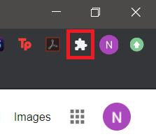

This icon should appear near the X button to close the w indow . Click it once for a m enu to pop up. For the next steps, click the buttons in the red boxes.

*Chrome Extensions button*

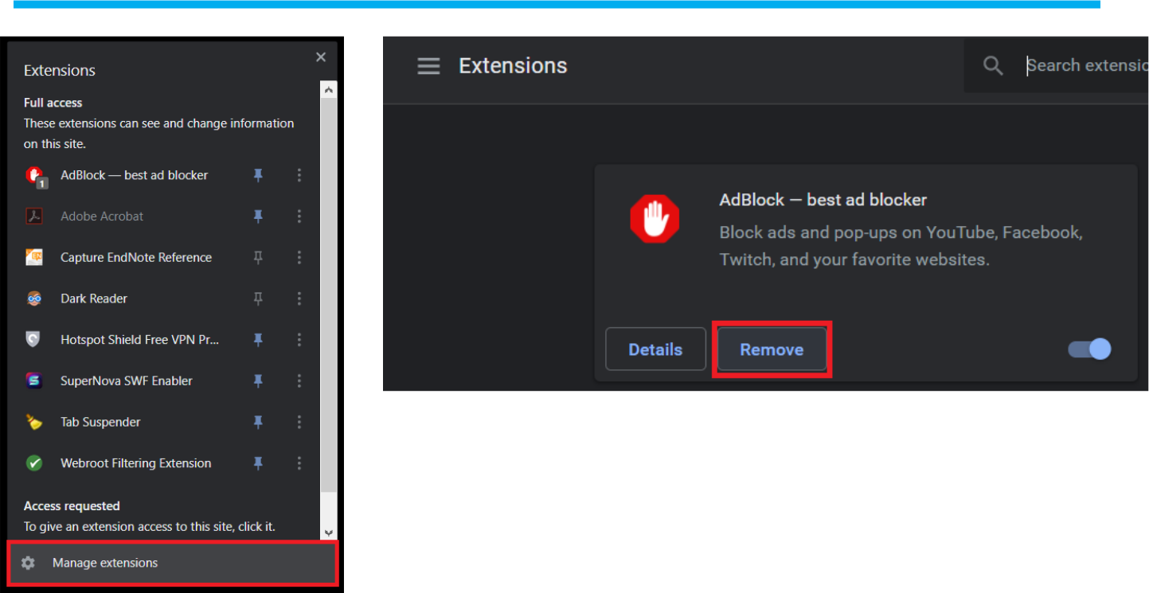

*Click this second*

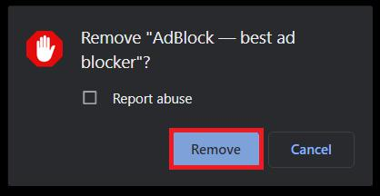

*Click this first*

*Click this third*



**THIS USER DOCUMENT HAS BEEN PREPARED BY**

N icholas H alstead at Virginia Tech

EXAMPLES OF EXTENSIONS

Som e extensions Iuse are: AdBlock, Tab Suspender,

H otspot Shield, and a Adobe Acrobat.



These are free extensions Iuse:



AdBlock is an extension that can block som e ads on the page to m ake w eb brow sing easier



Tab Suspender can put chrom e tabs on pause w hen not recently in use to m ake brow sing and your com puter faster



H otspot Shield is a VPN , m eaning it can route your connection through another location for your privacy from others



Adobe Acrobat is a usefultoolfor editing PD Fs and other docum ents



HOW TO USE EXTENSIONS?

Providing the fulldetails on how to use each Chrom e Extension individually w ould take forever, so instead this section w illhighlight how to learn about each one.



Follow the instructions on how to rem ove an extension, but instead ofpressing the button " Rem ove", press the button that says " D etails" instead. This w illgive you details such as its description, version num ber, and a button at the bottom to rem ove it ifyou w ish.

The button labelled " View in Chrom e W ebstore" allow s you to see the originalpage, w hich is likely to have im portant inform ation ifyou need to be rem inded.

See photos below for clarification.

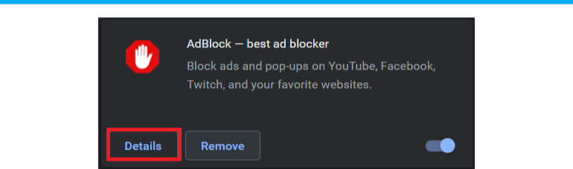

*The Details button for the AdBlock extension*

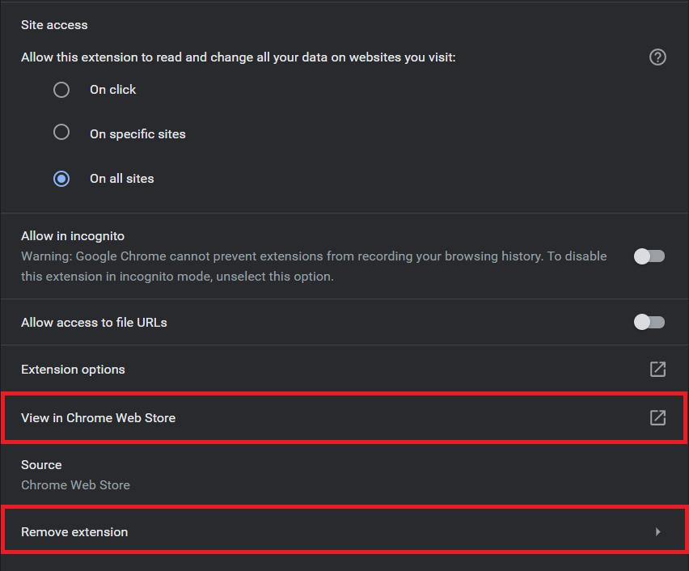

*Key buttons at the bottom of the details page mentioned before*



**THIS USER DOCUMENT HAS BEEN PREPARED BY**

N icholas H alstead at Virginia Polytechnic Institute and State University